Assignment – 2

* **Making connection: a. Tree**

**b. Bus**

**c. Ring**

**d. Mesh**

* **Tree:**

Step 1 : Take 1 root switch (Core Layer).

Step 2 : Take 2 distribution switches (Middle Layer).

Step 3 : Take 4 access switches (Edge Layer).

Step 4 : Take multiple PCs.

Step 5 : Connect root switch → distribution switches (Fiber/Copper).

Step 6 : Connect distribution switches → access switches (Straight-Through).

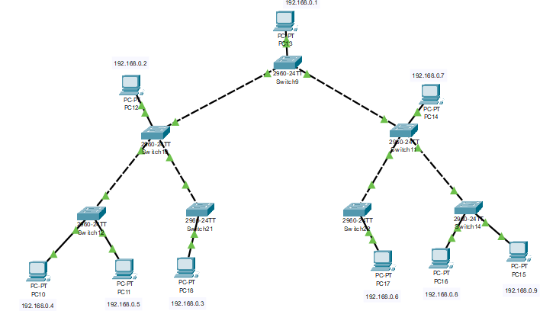Step 7 : Connect PCs → access switches (Straight-Through).

Step 8 : Let’s test the network from “PC10” by writing below command in

PC10’s command prompt or CMD & check replies come or not from

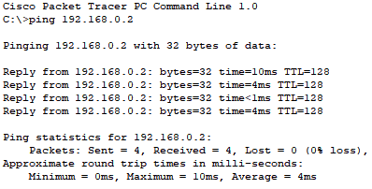other PC’s**:**

Replies are successful, the connection works!